32.49: a) Find the force on you due to the momentum carried off by the light:
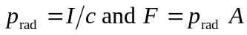 gives 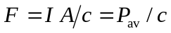

Then
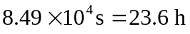
The radiation force is very small. In the calculation we have ignored any other forces on you.
b) You could throw the flashlight in the direction away from the ship. By conservation of linear momentum you would move toward the ship with the same magnitude of momentum as you gave the flashlight.

